Ssh tunnel

[2020-05-04 14:56.07] ~

[thult28.VHT-THULT28] ➤ **ssh-keygen**

Generating public/private rsa key pair.

Enter file in which to save the key (/home/mobaxterm/.ssh/id_rsa):

Enter passphrase (empty for no passphrase):

Enter same passphrase again:

Your identification has been saved in /home/mobaxterm/.ssh/id_rsa.

Your public key has been saved in /home/mobaxterm/.ssh/id_rsa.pub.

The key fingerprint is:

SHA256:OSlrHI1FZhy902ud3iGiA3qC5i6kgC+Vdkvzswo61I0 thult28@VHT-THULT28

The key's randomart image is:

+---[RSA 2048]----+

| .=o |

| +. . |

| . o |

| + oo . |

|. ..o + S . o . |

|oo+E+o = . .o.o. |

|=+.o.+= . .......|

|+o.+.+o. o . .|

|.o=o..+o . |

+----[SHA256]-----+

[2020-05-04 14:56.16] ~

[thult28.VHT-THULT28] ➤ ssh-copy-id -i ~/.ssh/id_rsa.pub ont@172.16.32.73

/bin/ssh-copy-id: INFO: attempting to log in with the new key(s), to filter out any that are already installed

/bin/ssh-copy-id: INFO: 1 key(s) remain to be installed -- if you are prompted now it is to install the new keys

Number of key(s) added: 1

Now try logging into the machine, with: "ssh 'ont@172.16.32.73'"

and check to make sure that only the key(s) you wanted were added.

[thult28.VHT-THULT28] ➤ cp .ssh/id_rsa.pub /drives/d/

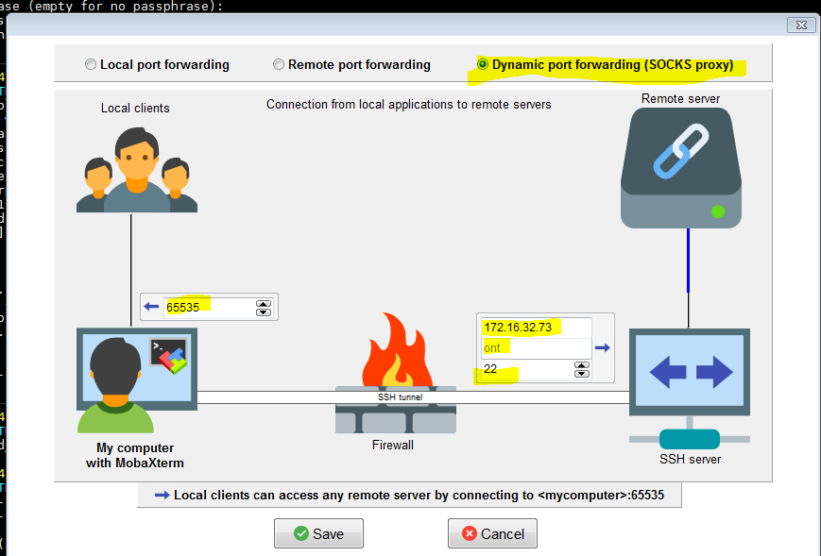

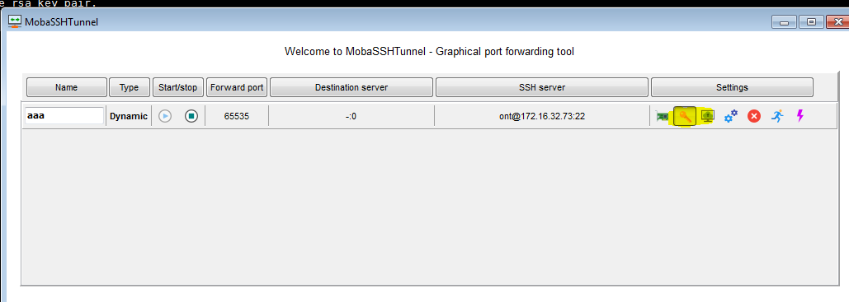

Choose key icon, input file at /drives/d/ id_rsa.pub import

Click to start

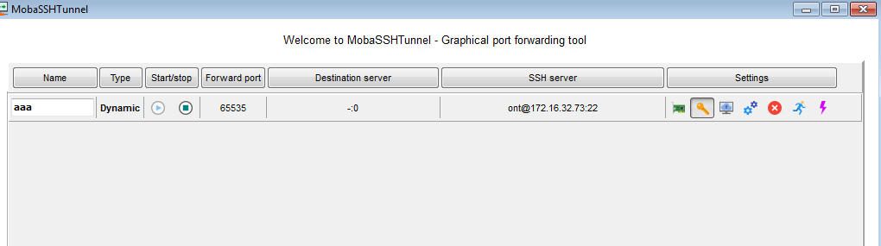

Config at firefox:

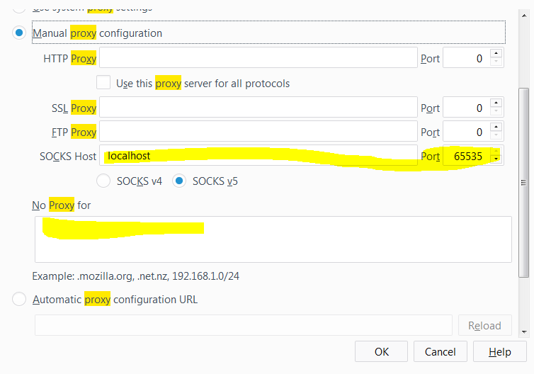

ssh -D 65535 ont@172.16.32.73